John Szostak

**Matsumoto, Shunsuke (松本竣介, 1912-1949)**

Matsumoto Shunsuke was an oil painter and essayist active in the years up to and through the Pacific War. His best-known paintings, most of which feature figures in urban landscapes, include several self-portraits such as *Standing Figure*  (1942). Matsumoto contracted spinal meningitis at the age of eleven which eventually led to the loss of his hearing, an event that steered him towards the career of professional artist, and encouraged him to become immersed in reading and the literary arts. Later, it also rendered him ineligible for the draft. At seventeen he dropped out of high school and moved to Tokyo where he studied oil painting at the Pacific School of Fine Arts (Taiheiyô Bijutsu Gakkô) for three years. In 1935 he became a member of the avant-garde NOVA Art Society the first of several exhibition collective and artist groups in which he would participate, including the Nikakai, the Nine-Room Society (Kyûshitsukai), and the Newcomers Painting Society (Shinjin Gakai). Like Ai Mitsu, Asô Saburô, and others with whom he associated, Matsumoto expanded his style to accommodate expanded interest in abstraction and Surrealism in Japan in the 1930s, but he largely retained his interest in painting intimate portraits, set in un-idealised cityscapes, throughout his career.

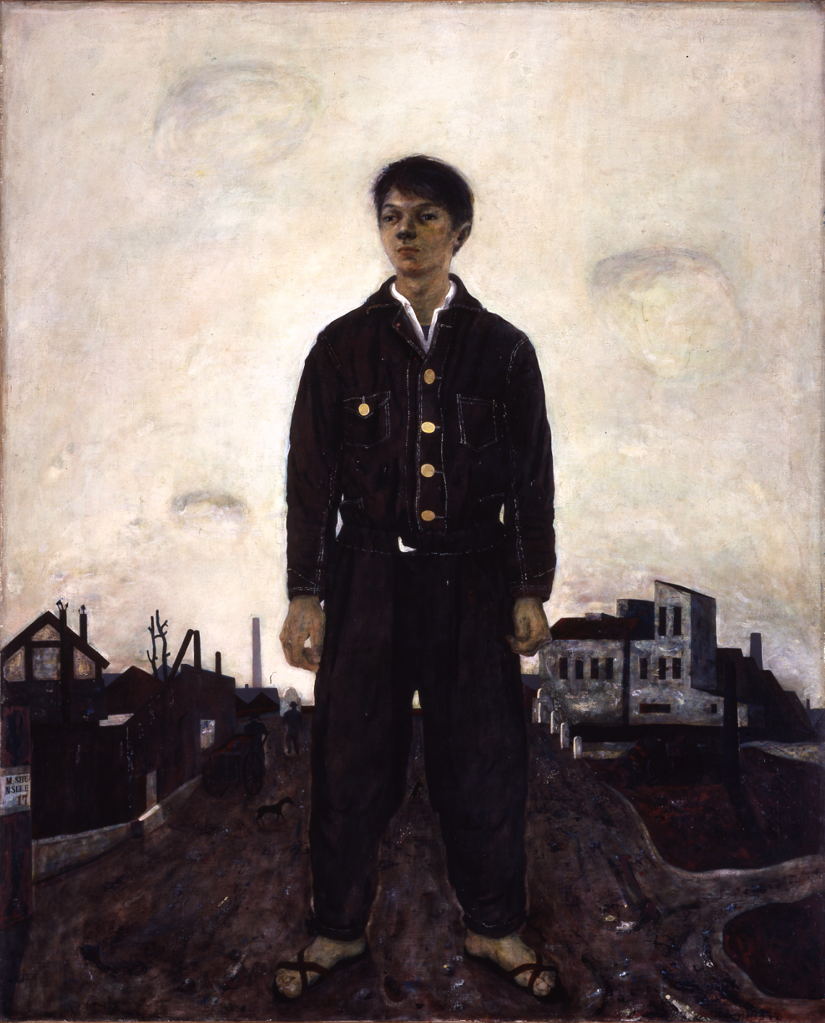

Matsumoto Shunsuke, *Standing Figure*, 1942. Oil on canvas. Collection: Kanagawa Prefectural Museum of Modern Art.

In addition to painting, Matsumoto helped found and edit the magazine *Notebook* (*Zakkichô*), and published essays in several prominent publications, the most important of which was undoubtedly *The Living Artist*. *The Living Artist* (*Ikiteiru Gaka*) was a response to an article entitled *The National Defense State and The Fine Arts: What Should Artists Do?* (*Kokubô kokka to bijutsu: Gaka wa nani o nasubeki ka*) published in the art journal *Mizue* in January 1941. The article was the transcript of roundtable discussion led by staff officers of the Japanese army’s Information Section, the message of which Mark Sandler described as “nothing less than a blunt warning of the government’s intention to bring the entire art world under its tight control.” In particular, the discussants railed against artists who asserted their creative independence by making “art for art’s sake,” and argued that the only true art is that which is created in service to the nation. In opposition, Matsumoto argued that art’s ultimate relevance is its capacity to nurture the human spirit, and that the proletarian, propagandistic art of the sort promoted by the Army Information Section would impoverish the nation’s spiritual life. “We do not stop painting,” he wrote, “even in the most difficult environment, because the act of creating means for us our step-by-step, gradual growth as human beings.” It is through producing art with complete creative freedom, he explained, that Japanese artists would build the foundations for an ideal nation.

**References and further reading:**

Matsumoto Shunsuke. (April 1913) “Ikiteiru gaka,” *Mizue* no. 437, 477-90.

Mizusawa Tsutomu. (1992) “Matsumoto Shunsuke hoyden” (“Biography of Matsumoto Shunsuke) in *Nihon Kindai Bijutsu* (Modern Japanese Art), vol. 10Tokyo: Otsuki Shoten, 141-44.

Sandler, Mark H. (Fall 1996) “The Living Artist: Matsumoto Shunsuke’s Reply to the State.” *Art Journal*, vol. 55, no. 3, 74-82.